Social Studies
Vocabulary for Chapters 3-5

Stone Age: This period of time took place from about 2 million years ago until 3000 B.C.E. It is named this because humans made tools out of stone.
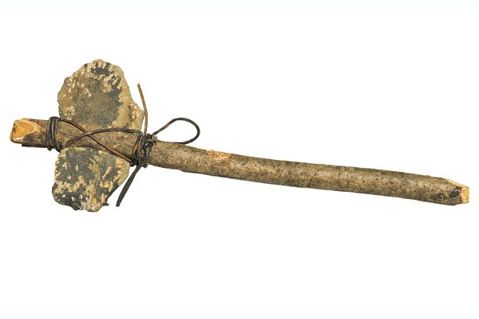
Paleolithic Age: This period of time is also known as the Old Stone Age. People got their food by hunting and gathering and they did not live in the same place for very long.
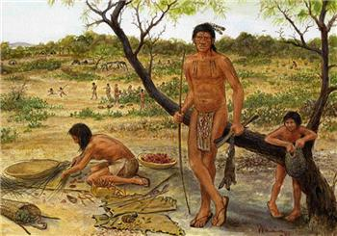
Neolithic Age: This period of time is also known as the New Stone Age. People learned to raise animals and crops for food. They settled down in an area to live in one place.
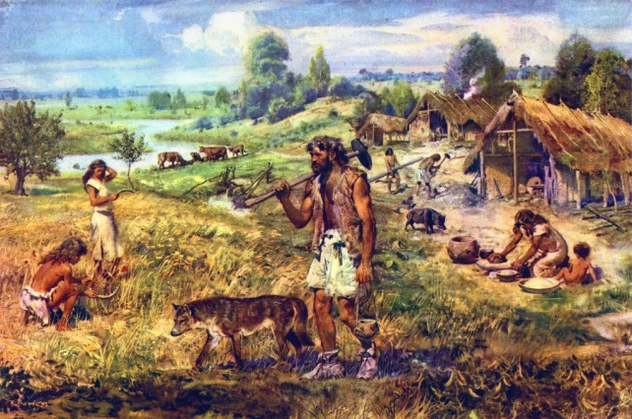
Domesticate: Early farmers learned to raise animals and use them for their own purposes. They got milk from cows and goats and they also used them to carry heavy things.
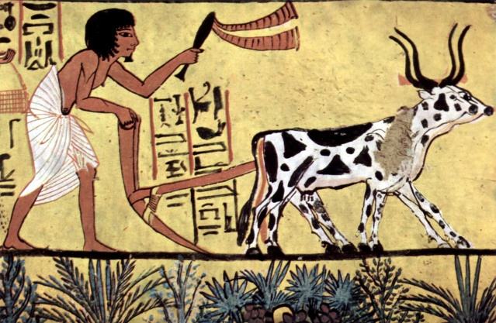
Agriculture: The business of farming (raising animals and growing crops). This invention of agriculture occurred at the beginning of the Neolithic Age. This is one of the most important advances in history because it was the first time people had a stable food supply.
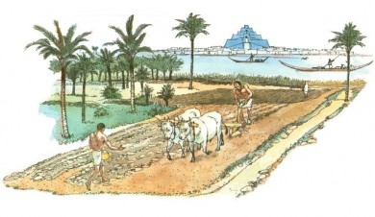
Trade: The business of buying and selling or exchanging items. This was a major change that occurred in the Neolithic Age.
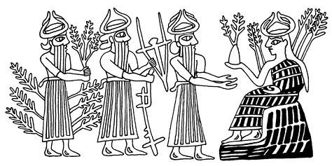

Ore: A mineral mined for its valuable uses. Women used the red ore called hematite to rub on their lips to make them redder.
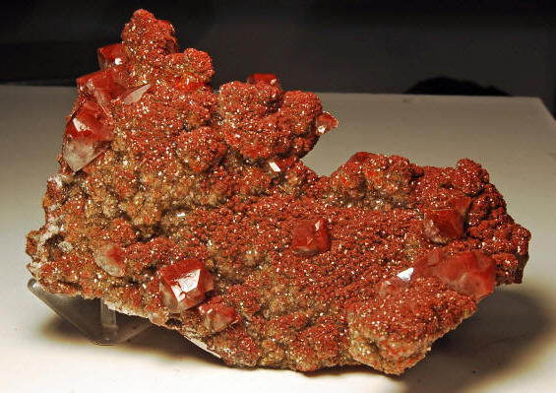
Mesopotamia: This is a Greek word that means “the land between two rivers” and was an area were villages were located. This is now modern-day Iraq.
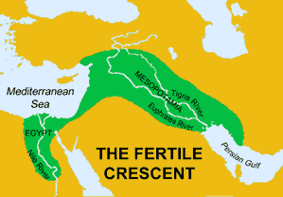
Sumer: This is the southern part of Mesopotamia where the first cities appeared.
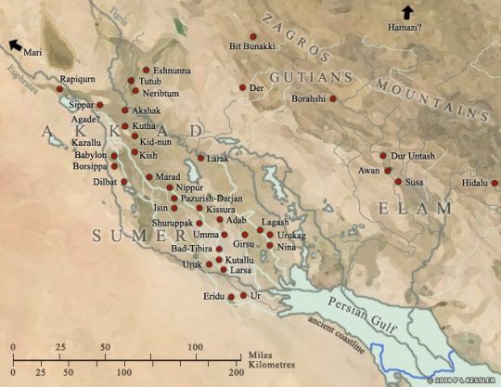

City-states: The cities in Sumer were like their own small, independent countries. They had their own ruler and food.
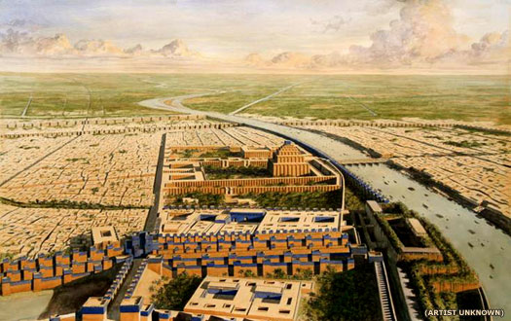
Irrigation system: A means of supplying land with water. In some parts of Mesopotamia, there was little rain and farmers needed a way to water their crops.
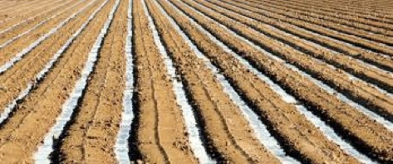
Levee: A wall of earth built to prevent a river from flooding its banks. They blocked the water from flooding when needed and when the land was dry, they poked holes in the levee to let some water drain through.

Culture: A characteristic of civilization that includes the beliefs and behaviors of a society or group of people.
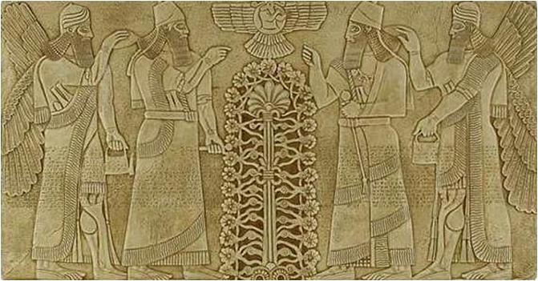

Civilization: A culture marked by developments in arts, sciences, government, and social structure.
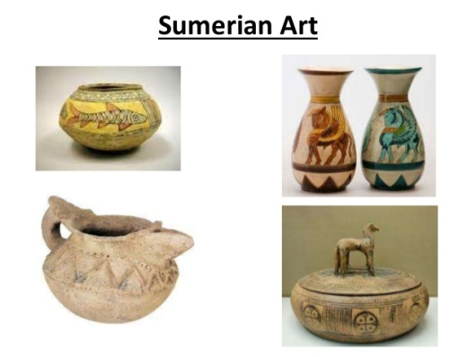
Social structure: The way a civilization is organized. This included different social levels and jobs.
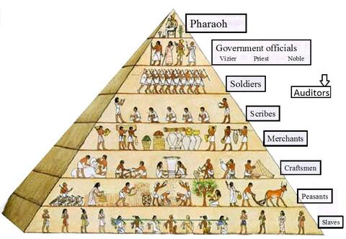
Status: Importance. People who had higher levels of the social structure had greater status than others.
Chariot: A two-wheeled vehicle pulled by a horse.
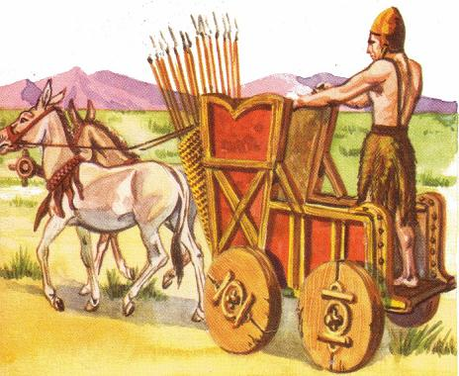
Scribe: A person who writes. During that time period, these people helped record the laws.
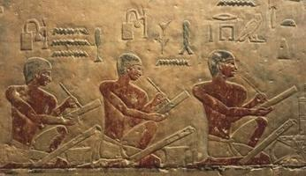
Ziggurat: An ancient Mesopotamian temple tower. The Sumerians built these towers and believed that gods lived in them. They even built stairs so the gods could climb down to Earth!
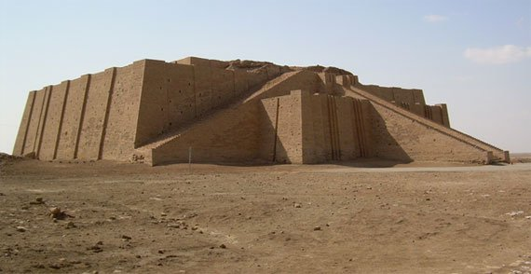
Lyre: A string instrument that looks a bit like a harp.
